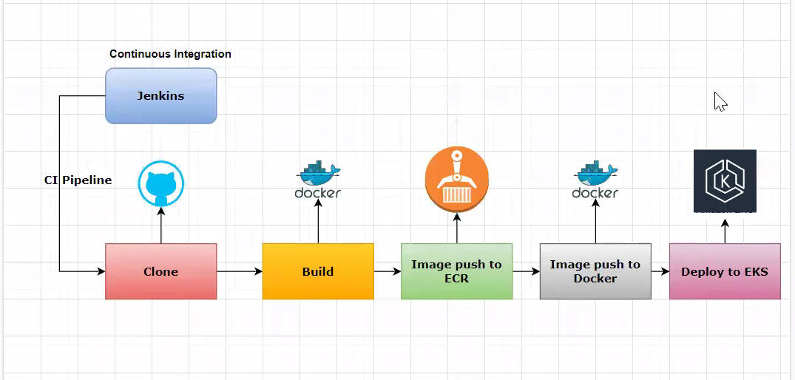

**Install docker.sh**

<https://raw.githubusercontent.com/Msocial123/docker-install-commands/master/docker-install.sh>

curl https://raw.githubusercontent.com/Msocial123/docker-install-commands/master/docker-install.sh | sudo bash

**Install AWS CLI and other components:**

[**https://raw.githubusercontent.com/Msocial123/k8-install-eks/master/eks-client.sh**](https://raw.githubusercontent.com/Msocial123/k8-install-eks/master/eks-client.sh)

curl https://raw.githubusercontent.com/Msocial123/k8-install-eks/master/eks-client.sh | sudo bash

Install Helm :

curl -fsSL -o get_helm.sh <https://raw.githubusercontent.com/helm/helm/main/scripts/get-helm-3>

chmod 700 get_helm.sh

./get_helm.sh

sudo chmod +x linux-amd64/helm && sudo mv linux-amd64/helm /usr/bin/helm

helm version --short

**Add Jenkins user:**

**sudo usermod –aG docker Jenkins**

**Install Below Plugins :**

**Install Docker**

**Configure Docker**

**Install AWS Credencials**

**Install AWS Steps**

**Add Docker Cloud :**

**Add AWS Credentials:**

**Docker Pipeline**

**Clone**

**Unit Tests**

**Scans**

**Static Source analysis with SonarQube**

Steps : We have to Configure the Aws Credencials – Jenkins – Manage Jenkins – Credencials – Select AWS Credenials